Title of the Submitted Paper (14 pt Cambria, bold)
Maria ANONIMOWA-KOWALSKA¹, Firstname LASTNAME², William F. ANONYMOUS³ (10 pt Cambria, Bold),
Corresponding author: Maria ANONIMOWA-KOWALSKA, email: maria.ano-ko@domain.com (9 pt Cambria, Plain)
¹ Affiliation 1, address 1 (9 pt Cambria, Plain)
² Affiliation 2, address 2 (9 pt Cambria, Plain)
³ Affiliation 3, address 3 (9 pt Cambria, Plain)
Abstract (10 pt Cambria, bold, left alignment) The main text of your article must be preceded by a concise abstract that highlights the major points of the paper (objectives, methods, findings). The summary should include up to 150 words, and must be formatted as follows: 10 pt Cambria, plain text, single line spacing. Please leave a space of 20 pt before and 10 pt after Abstract.

Keywords: 4-8 words/phrases which are representative for the paper – maximum 1 line (10 pt, plain)

1. Introduction (10 pt, bold, left alignment)
This document offers instructions on preparing your paper for the Vibrations in Physical Systems. This paper will be reviewed by two or more reviewers, and a decision on its acceptance will be conveyed to you.
This is a sample of the format of your full paper. Use Microsoft Word editor with A4 page size (210 × 297 mm), and set all margins (left, right, bottom and top) to 2.5 cm. Paper must be written in English, and should be 6 or 8 pages long. Use one-column format.
Paragraph indentation is 5 mm. The heading of each section should be written in 10 pt, left-justified and bold. Use Arabic numerals (1, 2, 3, …) for the sections' numbering. Please, leave a space of 10 pt before and 6 pt after the heading of each section. You can refer to a particular section by using the abbreviations “Sect.”, “Sects.” except at the beginning of a sentence. For example, “… as discussed in Sect. 1 …”, “As mentioned in Sects. 2 and 3, …”, “Section 2 includes …”.
2. Equations
All equations should be aligned to the center, and created with the Equation Editor; set font to Cambria Math, 10 pt. Please, leave a space of 6 pt before and after each equation (use settings of the line with the equation). Conventionally, most of mathematical symbols (e.g. scalar variables) are written in italics. The exceptions are: elementary functions (e.g. sin, cosh, arctan, log, exp, sign, Re, Im) – in plain font style; physical units (e.g. m, kg, N, m/s) – in plain font style; vectors and matrices (e.g. q, F, M, K) – in bold plain; abbreviations in subscript/superscript (e.g. min, max) – in plain font style; the characteristic (dimensionless) numbers (e.g. Re, Bi, St) – in plain font style.
Equations should be editable by the editorial office and not appear in a picture format. For example, quantity Z_{R} can be expressed in the following way:

$$Z_{R}=\frac{1}{S}\iint_{S}{\frac{p}{v_{n}}dS=\frac{1}{πa^{2}}}\int_{0}^{2π}{\int_{0}^{a}{r\left[Re\left(\frac{p}{v_{n}}\right)+jIm\left(\frac{p}{v_{n}}\right)\right]}drdφ,}$$ | (1)
where S is the area of the surface, $v_{n}=n∙v$is the outward normal component of velocity on the surface, and r denotes the cylindrical coordinate.
When it comes to equations in a matrix form, they can be written as
$M\ddot{q}=f(t, q, \dot{q})$, | (2)
$q\left(0\right)=q_{0}, \dot{q}\left(0\right)=u_{0}$, | (3)
where M is the mass matrix, q denotes the vector of generalized coordinates, and t is time.
If referred to explicitly in the text, equations must be numbered consecutively with Arabic numerals in parentheses on the right-hand side of the page. You can refer to a particular equation by using the abbreviations “Eq.”, “Eqs.” except at the beginning of a sentence. For example, “… as shown in Eq. (1) …”, “… Eqs. (2) and (3) describe …”, “Equation (1) indicates that …”.
3. Figures and tables
3.1. General remarks
Figures/tables should be placed as close as possible to the first reference to them in the text. However, do not split a paragraph by inserting a figure or a table. The number or size of figures/tables may cause that they are placed 1-2 pages before or after the paragraph where they are first mentioned.
Figures and tables should be numbered sequentially with Arabic numerals. Use the abbreviations “Fig.” and “Tab.” as labels (written in bold together with a number).
3.2. Figures
Figures must be placed with center alignment in the column (see Fig. 1). All symbols and numbers must be at least 6 pt font. The figure description should be typed below the illustration, center aligned. Please, leave a space of 6 pt before each figure, and 6 pt before and 6 pt after the figure caption.

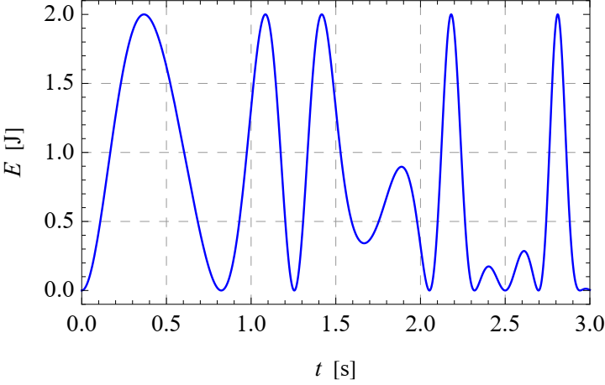
Fig. 1. Figure caption. (10 pt Cambria, plain, center alignment)
Figures should always be mentioned in the text. All schemas, graphs/diagrams and photographs must be referred to as figures. When referencing to illustrations, use the abbreviations “Fig.” and “Figs.” whenever they occur within a sentence. For example, “As shown in Fig. 1, …”, “… (see Figs. 1-3)“, “Figure 1 illustrates …”.
If a figure has multiple parts, insert additional labels, such as “(a)”, “(b)”, above each sub-figure. Explain all parts in the caption of the entire figure (see Fig. 2).
Illustrations should be suitable for reproduction. Line drawings should be true electronic output or good quality scans. Please make sure that your colour figures will be well visualized and printed in B&W. If the figure has been previously published elsewhere, obtain permission from the original publisher and include the permission wording in the figure caption.

(a) | (b)
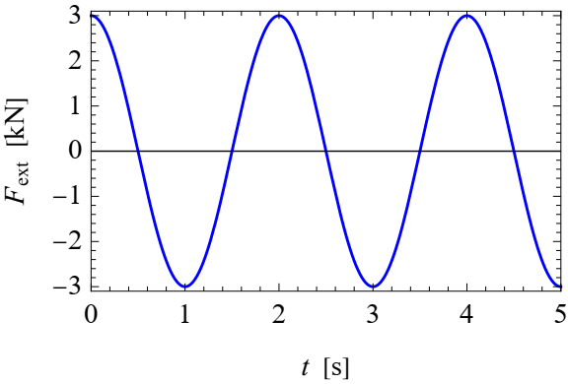 | 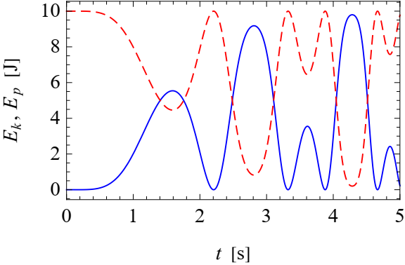
Fig. 2. Time histories of different quantities:
a) external force, b) kinetic (solid) and potential (dashed) energy of the system.

3.3. Tables
Tables must be placed center alignment in the paper. Descriptions must be placed above tables. Arrange your table as simply and clearly as possible. If possible, use only horizontal lines within a table, mainly to distinguish the column headings from the body of the table (see Tab. 1).
When referencing to figures or tables, use the abbreviations “Tab.” and “Tabs.” whenever they occur within a sentence. For example, “… as shown in Tab. 1 …”, “… (see Tabs. 1-3)“, “Table 1 contains …”.
Tab. 1. Table caption. (10 pt, plain, center alignment)
Quantity | Symbol | Unit | Value
Density (9 pt Cambria, Plain, Left Alignment) | $$ρ_{s}$$ | kg/m³ | 8960
Heat capacity | $$C_{1}$$ | J/(kg∙K) | 3.84e+2
 |  | m²/s | 1.16e-4

Please do not submit tables as graphics. Please, leave a space of 6 pt after each table, and 6 pt before and 6 pt after the table caption.

4. Conclusions

The paper will end with a conclusion paragraph in which the author(s) will specify the main results obtained and their possible applications (if any).

References must be numbered in order of appearance in the text (including citations in tables and legends) and listed individually at the end of the manuscript. We recommend preparing the references with a bibliography software package to avoid typing mistakes and duplicated references. Include the digital object identifier (DOI) for all references where available.

When citing references in the text, type the corresponding number in square brackets, e.g. [1], [1, 2] or [2-4]. You may also use the abbreviations “Ref.”, “Refs.”, for example “… (see Ref. [1])” or “… as discussed in Refs. [2-4]”.

Please, follow the above editing instructions faithfully, otherwise you will have to resubmit your paper. This will enable us to maintain uniformity in the Vibrations in Physical Systems. The better you look, the better we all look. Thank you for your cooperation and contribution.

Acknowledgments
Format the Acknowledgment and References headlines without numbering.

Additional information
The authors declare no competing financial interests.

References (10 pt, Bold, Left Alignment)
- K. Nakagami, K. Arima, T. Ueda, H. Kadou. On natural vibration and damping effect of tuned sloshing damper. J. Struct. Engng. 36:591–602, 1990. (10 pt font)
- M. Utsumi. Sound transmission in circular ducts of continuously varying cross-sectional area. Journal of Sound and Vibration 242(2):369-376, 2001. DOI: 10.1006/jsvi.2000.3331 (hyperlink)
- D. Łączna, F. Dłużniewski, T. Stręk. Analysis of eigenfrequencies of the foot prosthesis with auxetic component layer. Vibrations in Physical Systems 31(2):2020214, 2020. DOI: 10.21008/j.0860-6897.2020.2.14
- A. Bedford, W. Fowler. Engineering mechanics. Prentice Hall, New Jersey, 2002.
- Y. Chen, T. Luo, S. Liu, S. Zhang et al. Dadiannao: A machine-learning supercomputer. Proceedings of the 47th Annual IEEE/ACM International Symposium on Microarchitecture 609-622, 2014.

© 2021 by the Authors. Licensee Poznan University of Technology (Poznan, Poland). This article is an open access article distributed under the terms and conditions of the Creative Commons Attribution (CC BY) license (http://creativecommons.org/licenses/by/4.0/).

