Title of the submitted paper (14 pt Cambria, bold)
Firstname LASTNAME¹, Maria ANONIMOWA-KOWALSKA², John F. ANONYMOUS³ (10 pt Cambria, Bold)

¹ Affiliation 1, address 1, ORCID: 0000-0002-2411-8236 (9 pt Cambria, Plain)
² Affiliation 2, address 2, ORCID: number 2 (9 pt Cambria, Plain)
³ Affiliation 3, address 3, ORCID: number 3 (9 pt Cambria, Plain)

Corresponding author: Maria ANONIMOWA-KOWALSKA, email: maria.ano-ko@domain.com (9 pt Cambria, Plain)
Abstract (10 pt Cambria, bold, left alignment) The main text of your article must be preceded by
a concise abstract that highlights the major points of the paper (objectives, methods, findings). The summary should include up to 150 words and must be formatted as follows: 10 pt Cambria, plain text, single line spacing. Please leave a space of 20 pt before and 10 pt after Abstract.

Keywords: 3–10 words/phrases which are representative for the paper – maximum 1 line (10 pt, plain).
1. Introduction (10 pt Cambria, bold, left alignment)
This document offers instructions on preparing your paper for the Vibrations in Physical Systems. This paper will be reviewed by two or more reviewers, and a decision on its acceptance will be conveyed to you.
This is a sample of the format of your full paper. Use Word processing software (e.g. Microsoft Word) with A4 page size (210 × 297 mm), and set margins (left, right, bottom) to 2.5 cm and top margin to
2.8 cm. The paper must be written in English, preferably 8 – 12 pages long. Use one-column format,
10 pt Cambria and single interline.
Paragraph indentation is 5 mm. The heading of each section should be written in 10 pt, left-justified and bold. Use Arabic numerals (1, 2, 3, …) for the sections' numbering. Please, leave a space of 10 pt before and 6 pt after the heading of each section. You can refer to a particular section by using the abbreviations “Sect.”, “Sects.” except at the beginning of a sentence. For example, “… as discussed in Sect. 1 …”, “As mentioned in Sects. 2 and 3, …”, “Section 2 includes …”.
2. Equations
All equations should be aligned to the centre, and created with the Equation Editor; set font to Cambria Math, 10 pt. Please, leave a space of 6 pt before and after each equation (use settings of the line with the equation). Conventionally, most of the mathematical symbols (e.g. scalar variables) are written in italics. The exceptions are: elementary functions (e.g. sin, cosh, arctan, log, exp, sign, Re, Im) – in plain font style; physical units (e.g. m, kg, N, m/s) – in plain font style; vectors and matrices (e.g. q, F, M, K) – in the bold plain; abbreviations in subscript/superscript (e.g. min, max) – in plain font style; the characteristic (dimensionless) numbers (e.g. Re, Bi, St) – in plain font style.
Equations should be editable by the editorial office and not appear in a picture format. For example, quantity Z_{R} can be expressed in the following way:

$$Z_{R}=\frac{1}{S}\iint_{S}{\frac{p}{v_{n}}dS=\frac{1}{πa^{2}}}\int_{0}^{2π}{\int_{0}^{a}{r\left[Re\left(\frac{p}{v_{n}}\right)+jIm\left(\frac{p}{v_{n}}\right)\right]}drdφ,}$$ | (1)
where S is the area of the surface, $v_{n}=n∙v$is the outward normal component of velocity on the surface, and r denotes the cylindrical coordinate.
When it comes to equations in a matrix form, they can be written as
$M\ddot{q}=f(t, q, \dot{q})$, | (2)
$q\left(0\right)=q_{0}, \dot{q}\left(0\right)=u_{0}$, | (3)
where M is the mass matrix, q denotes the vector of generalized coordinates, and t is time.
If referred to explicitly in the text, equations must be numbered consecutively with Arabic numerals in parentheses on the right-hand side of the page. You can refer to a particular equation by using the abbreviations “Eq.”, “Eqs.” except at the beginning of a sentence. For example, “… as shown in Eq. (1) …”,
“… Eqs. (2) and (3) describe …”, “Equations (1) – (3) indicate that …”.
3. Figures and tables
3.1. General remarks
Figures/tables should be placed as close as possible to the first reference to them in the text. However, do not split a paragraph by inserting a figure or a table. The number or size of figures/tables may cause that they are placed 1 – 2 pages before or after the paragraph where they are first mentioned.
Figures and tables should be numbered sequentially with Arabic numerals (labels written in bold together with a number).
3.2. Figures
Figures must be placed with centre alignment in the column (see Fig. 1). All symbols and numbers must be at least 6 pt font. The figure description should be typed below the illustration, centre-aligned. Please, leave a space of 6 pt before each figure, 6 pt before and 6 pt after the figure caption.

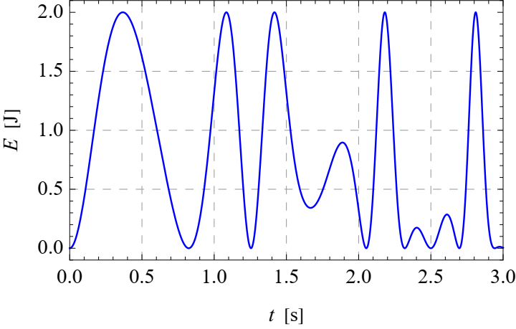
Figure 1. Figure caption. (10 pt Cambria, plain, centre alignment)
Figures should always be mentioned in the text. All schemas, graphs/diagrams and photographs must be referred to as figures. When referencing to illustrations, use the abbreviations “Fig.” and “Figs.” whenever they occur within a sentence. For example, “As shown in Fig. 1, …”, “… (see Figs. 1 – 3)“, “Figure 1 illustrates …”.
If a figure has multiple parts, insert additional labels, such as “a)”, “b)”, above each sub-figure. Explain all parts in the caption of the entire figure (see Fig. 2).
Illustrations should be suitable for reproduction. Line drawings should be true electronic output or good quality scans. Please make sure that your colour figures will be well visualized and printed in B&W. If the figure has been previously published elsewhere, obtain permission from the original publisher and include the permission wording in the figure caption.

a) | 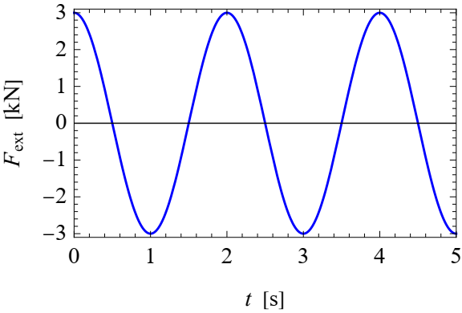 | b) | 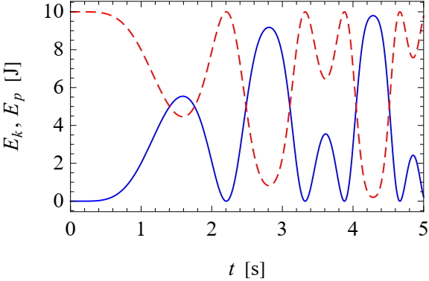
Figure 2. Time histories of different quantities:
a) external force, b) kinetic (solid) and potential (dashed) energy of the system.
3.3. Tables
Tables must be placed centre alignment in the paper. Descriptions must be placed above tables. Arrange your table as simply and clearly as possible. If possible, use only horizontal lines within a table, mainly to distinguish the column headings from the body of the table (see Tab. 1).
When referencing to figures or tables, use the abbreviations “Tab.” and “Tabs.” whenever they occur within a sentence. For example, “… as shown in Tab. 1 …”, “… (see Tabs. 1 – 3)“, “Table 1 contains …”.
Table 1. Table caption. (10 pt, plain, centre alignment)
Quantity | Symbol | Unit | Value
Density (9 pt Cambria, Plain, Left Alignment) | $$ρ_{s}$$ | kg/m³ | 8960
Heat capacity | $$C_{1}$$ | J/(kg∙K) | 3.84e+2
Temperature range | T | K | 293.15 – 353.15
Kinematic viscosity | ν | m²/s | 1.16·10⁻⁴

Please do not submit tables as graphics. Please, leave a space of 6 pt after each table, and 6 pt before and
6 pt after the table caption.

4. Conclusions

The paper will end with a conclusion paragraph in which the author(s) will specify the main results obtained and their possible applications (if any).

References must be numbered in order of appearance in the text (including citations in tables and legends) and listed individually at the end of the manuscript. We recommend preparing the references with a bibliography software package to avoid typing mistakes and duplicated references. Include the digital object identifier (DOI) for all references where available.
When citing references in the text, type the corresponding number in square brackets [ ], and place before the punctuation; for example [1], [1, 2] or [2–4]. You may also use the abbreviations “Ref.”, “Refs.”, for example, “… (see Ref. [1])” or “… as discussed in Refs. [2–4]”.
References should be described as it is presented in the References section, depending on the type of work: journal articles [1], books and book chapter [2, 3], unpublished materials intended for publication
[4, 5], conference proceedings [6], and thesis [7]. For clarity, a general template of the reference list is presented on the last page of this document (please, delete that page from your submission).

Please, follow all editing instructions faithfully, otherwise, you will have to resubmit your paper. This will enable us to maintain uniformity in the Vibrations in Physical Systems. The better you look, the better we all look. Thank you for your cooperation and contribution.

Acknowledgments
Format the Acknowledgment, Additional information and References headlines without numbering.

Additional information (this section is obligatory)
The author(s) declare: no competing financial interests and that all material taken from other sources (including their own published works) is clearly cited and that appropriate permits are obtained.

References (10 pt, Bold, Left Alignment)
- N. Popplewell, C.N. Bapat, K. McLachlan; Stable periodic vibroimpacts of an oscillator; J. Sound Vib., 1983, 87(1), 41–59; DOI: 10.1016/0022-460X(83)90438-8 (10 pt font)
- W. Nowacki; Teoria Sprężystości (in Polish); PWN, 1970
- I. Newton; Philosophiae Naturalis Principia Mathematica, Volume 1 (in Latin); Nabu Press, 2014
- E. Ott; Chaos in Dynamical Systems, 2nd ed.; Cambridge University Press, 2002
- P. Wriggers, G. Zavarise; Computational contact mechanics; In: Encyclopedia of Computational Mechanics, 2nd ed.; E. Stein, R. de Borst, T.J.R. Hughes, Eds.; Wiley, 2004, 2, 195–226
- J.W. Stephens, Z. Wang; Vibration of sandwich beams: experimental and numerical studies; Imperial College London, 2022, manuscript in preparation
- S. Lee, D.E. Nelson, P. White; Near-resonant dynamics of oceanic cable structures; Nonlinear Dyn., 2022, accepted
- V. Settimi, E. Saetta, G. Rega; Passive/active thermal dynamics in the coupled nonlinear vibrations of laminated plates; Proceedings of the 9th European Nonlinear Dynamics Conference, Budapest, Hungary, June 25-30, 2017; G. Stépán, G. Csernák, Eds.; Congressline Ltd.: Budapest, Hungary, 2017, 422
- S. Masri; Analytical and Experimental Studies of Impact Dampers; PhD Thesis, California Institute of Technology, 1965
- ANSI/ASHRAE 41.1-2020; Standard Methods for Temperature Measurement, 2020
- PN-EN ISO 14120:2016-03; Safety of machinery – Guards – General requirements for the design and construction of fixed and movable guards, 2016
- Authorship and contributorship; https://publicationethics.org/authorship (accessed on 2023.01.01)

© 2025 by the Authors. Licensee Poznan University of Technology (Poznan, Poland). This article is an open access article distributed under the terms and conditions of the Creative Commons Attribution (CC BY) license (http://creativecommons.org/licenses/by/4.0/).

General template of the reference list (the References section):
JOURNAL ARTICLES:
1. A.B. Author 1, C.D. Author 2; Title of the article; (Abbreviated) Journal Name, Year, Volume(number), Page range or Article number; DOI: identifying number
BOOKS AND BOOK CHAPTERS:
2. A. Author 1, B. Author 2; Book Title, 3rd ed.; Publisher, Year
3. A. Author 1, B. Author 2; Title of the chapter; In: Book Title, 2nd ed.; A. Editor 1, B. Editor 2, Eds.; Publisher, Year, Volume(number), Page range
4. A. Author 1, B. Author 2; Non-English Titles (in language); Publisher, Year
UNPUBLISHED MATERIALS INTENDED FOR PUBLICATION:
5. A.B. Author 1, C. Author 2; Title of unpublished work (optional); Correspondence Affiliation, Year, Status (manuscript in preparation; to be submitted). DOI number (if available)
6. A.B. Author 1, C. Author 2; Title of unpublished work; (Abbreviated) Journal Name, Year, Stage of publication (submitted; accepted; in press); DOI: identifying number (if available)
CONFERENCE PROCEEDINGS:
7. A.B. Author 1, C.D. Author 2, E.F. Author 3; Title of presentation; In: Title of the Collected Work (if available); Proceedings of the Name of the Conference, Location of Conference, Country, Date of Conference; Editor 1, Editor 2, Eds. (if available); Publisher, Year, Abstract number (optional), Page range (optional); DOI: identifying number (if available)
THESIS:
8. A.B. Author; Title of Thesis; Level of Thesis, Degree-Granting University, Location of University, Year of Completion
STANDARDS:
9. Standard signature; Standard title, Year
INTERNET SOURCES:
10. Website name; URL (accessed on YYYY.MM.DD)

